**BNP Paribas UAE Branches**

**Pillar III - 31 Dec 2022**



CONTENTS

**EXECUTIVE SUMMARY** 3

**BNP PARIBAS GROUP** 4

**FINANCIAL PERFORMANCE: year 2022** 5

**CAPITAL COMPOSITION** 6

**CAPITAL MANAGEMENT** 6

**RISK MANAGEMENT** 8

**CREDIT RISK** 8

**MARKET RISK** 12

**OPERATIONAL RISK** 13

**LIQUIDITY RISK** 14

**LEVERAGE RATIO** 15

**REMUNERATION** 16

**APPENDIX** 17

# **EXECUTIVE SUMMARY**

BNP Paribas UAE branches are branches of BNP Paribas S.A. (the “Bank” or the “Head Office”) incorporated and domiciled in France. The Branches operates under the Corporate and Institutional Banking division of BNP Paribas S.A. BNP Paribas UAE scope of consolidation is:

• BNP Paribas Dubai branch

• BNP Paribas Abu Dhabi branch

This report is in respect of the year ended 31 December 2022, including comparative information (where applicable) for the year ended 31 December 22.

**BNP Paribas Group disclosures**

BNP Paribas employs a predominantly centralised approach to risk management throughout the group. As such, BNP Paribas UAE branches’ approach to risk management follows group policies and procedures as a minimum standard. This report should thus be read in conjunction with the group Registration document. Where appropriate this document provides links to the BNP Paribas SA Group Registration document and annual financial report for the year ended 31 December 2022:

*Group Risk report:*

<https://invest.bnpparibas.com/en/registration-documents-annual-financial-reports>

*Group Compensation report:*

<https://invest.bnpparibas.com/en/compensation-regulated-employees>

# **BNP PARIBAS GROUP**

BNP Paribas is Europe’s leading provider of banking and financial services. It operates in 65 countries and employs 193,122 Full-Time Equivalent workforce. It holds key positions in its three main areas of activity:

* Retail Banking (Retail Banking networks in Europe, Africa and America),
* Investment & Protection Services (solutions in savings, investment and protection solutions)
* Corporate and Institutional Banking (tailored financial solutions for our corporate and institutional clients).

**BNP Paribas UAE branches:**

This Pillar III report is prepared on a consolidated basis. The scope of consolidation is:

* BNP Paribas Dubai branch
* BNP Paribas Abu Dhabi branch

BNP Paribas Abu Dhabi and BNP Paribas Dubai are branches of BNP Paribas SA.

BNP Paribas Abudhabi branch was set up in 1973 and BNP Paribas branch in Dubai set up a year later in 1974. BNP Paribas UAE branches are licensed by the Central Bank of UAE.

BNP Paribas UAE branches belong to Corporate and Institutional Banking of BNP Paribas group organisation

# **FINANCIAL PERFORMANCE: year 2022**

**Statement of Financial Position**

Below is an extract of Statement of Financial position from the BNP Paribas UAE Branches’ annual financial statements for the year ended 31 December 2022 and comparative information for 31 December 2021.

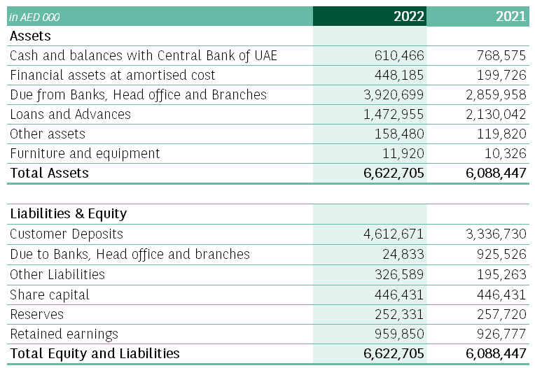

**Statement of Comprehensive Income**

Below is an extract of Statement of Comprehensive Income from the BNP Paribas UAE Branch’s annual financial statements for the year ended 31 December 2022 and comparative information for 31 December 2021.

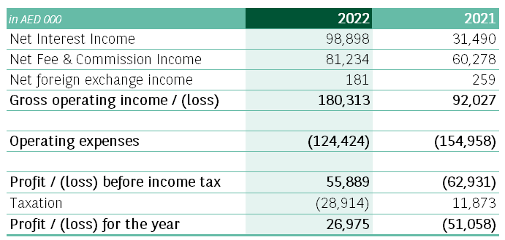

# **CAPITAL COMPOSITION**

BNP Paribas UAE branches has complied with all the regulatory requirements in relation to capital. The Branch’s regulatory capital is analysed into one tier:

* Tier 1 capital, which includes paid up capital, retained earnings, other reserves and comprehensive income after any regulatory adjustments that are required for capital adequacy purposes.
* Tier 2 capital which includes eligible general provisions as required by Central bank of UAE.

As of 31 Dec 2022, the branch’s regulatory capital is as follows:

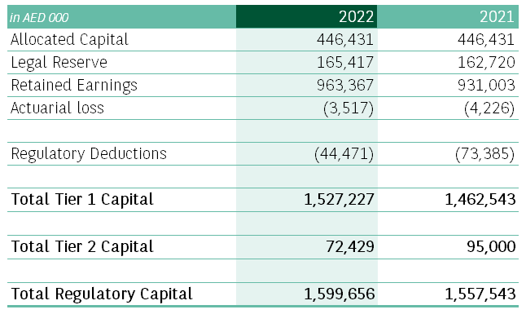

**Pillar I risk-weighted assets and capital requirements**

Below are the risk-weighted assets (“RWA”) and capital ratio as at 31 December 2022:

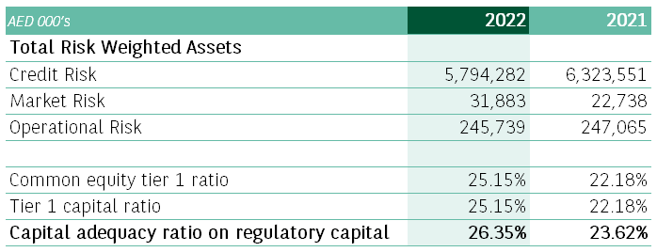

# **CAPITAL MANAGEMENT**

To ensure the Group’s sustainability, the Bank must maintain an adequate level of capital with respect to the risks to which it is exposed and its strategy. Capital is a rare and strategic resource, which requires stringent, clearly defined, rigorous management according to an approach, which takes account of the needs and demands of stakeholders, including shareholders, supervisors, creditors and depositors.

**Objectives:** BNP Paribas’ capital management:

* is governed by policies and procedures which make it possible to understand, document and supervise capital management practices throughout the Bank
* takes risk measurement into account to determine the use of the capital;
* considers capital requirements and resources under normal operating conditions, as well as under situations of severe, but plausible stress;
* presents a forward-looking vision of the Bank’s capital adequacy to the Executive Management;
* allocates the capital constraint to the business lines in keeping with their strategic objectives;
* complies with the Internal Capital Adequacy Assessment Process (ICAAP) and is consistent with the Risk Appetite Framework;
* is monitored by an appropriate governance.

**Capital Management at Central Level:**

BNP Paribas’ capital management aims to ensure and verify that the Group has adequate capital to comply with the regulatory capital ratios, as well as specific requirements. To ensure its capital adequacy, the Group abides by the following principles:

* maintaining the capital at an appropriate level in view of BNP Paribas’ activities, risk appetite, growth and strategic initiatives;
* maintaining BNP Paribas’ capital at a level which complies with regulatory requirements;
* keeping a balance between capital adequacy and return on capital;
* meeting its obligations vis-à-vis creditors and counterparties, at each due date;
* continuing to operate as a financial intermediary

**Capital Management at BNP Paribas UAE Level:**

The Group has to allocate available capital among its different entities. To ensure a free and efficient flow of capital throughout the Group, the capital allocation process within the Group is centralised at head office level. It is mainly based on two principles: compliance with local regulatory requirements and analysis of the local business needs of the entity and growth prospects. In line with these two principles, the aim is to minimise capital dispersion. With respect to the first principle, the local Chief Financial Officers are responsible for the daily management and reporting of their entities capital requirements. When a capital need arises, it is analysed on a caseby-case basis by the Group, taking into consideration the entity’s present position and future strategy. Furthermore, each year, the Group manages the earnings repatriation process. The Group general policy stipulates that the entire distributable profit of every entity, including retained earnings, must be paid out. This policy ensures that the capital remains centralised at the BNP Paribas SA level and also contributes to reducing the foreign exchange risk. Exceptions are considered on a case-by-case basis. Local Chief Executive Officers are responsible for ensuring the ongoing financial viability and competitiveness in terms of capital, where relevant. However, any capital action requested is assessed by and subject to authorisation from head office. With respect to the second principle, the needs of each entity are analysed by dedicated teams in light of the Group’s strategy in the relevant country, the entity’s growth prospects and the macroeconomic environment. In addition, every year the Group examines the branches’ capital allocations in order to maintain an adequate level of capital in light of the different regulations.

# **RISK MANAGEMENT**

*Details about strategies, processes and organization of risk management within BNP Paribas group can be found as part of its Registration Document, at:* <https://invest.bnpparibas.com/en/registration-documents-annual-financial-reports>

Risk management is central to the banking business and is one of the cornerstones of operations for the BNP Paribas Group. BNP Paribas has an internal control system covering all types of risks to which the Group may be exposed, organised around three lines of defence:

* As the first line of defence, Internal Control is the business of every employee, and the heads of the operational activities are responsible for establishing and running a system for identifying, assessing and managing risks according to the standards defined by the functions exercising an independent control in respect of a second level of control
* The main control functions within BNP Paribas ensuring the second line of defence are the Compliance, Risk and Legal Functions. Their Heads report directly to Chief Executive Officer and account for the performance of their missions to the Board of directors via its specialised committees
* General Inspection provides a third level of defence. It is responsible for the periodic control.

**General Responsibilities of the RISK and Compliance Functions:**

Responsibility for managing risks primarily lies with the divisions and business lines that are at the origin of the underlying transactions. RISK continuously performs a second-line control over credit and counterparty

risks, market risk, interest rate and foreign exchange rate risks on the banking book, liquidity risks, insurance risks, and operational risk, including technological and cybersecurity risks, over data protection risks, modelling risks and environmental and social risk factors, as well as the associated governance risks.

As part of this role, it must ascertain the soundness and sustainability of the business commercial developments and their overall alignment with the risk appetite target set by the Group. RISK’s remit includes formulating recommendations on risk policies, analysing the risk portfolio on a forward-looking basis, approving corporate loans and trading limits, guaranteeing the quality and effectiveness of monitoring procedures and defining or validating risk measurement methods. RISK is also responsible for ensuring that all the risk implications of new businesses or products have been adequately assessed.

Compliance has identical responsibilities as regards compliance and reputation risks. It plays an important oversight and reporting role in the process of validating new products, new business activities and exceptional transactions. By issuing opinions and decisions, and performing oversight and second-level controls, Compliance provides reasonable assurance as to the effectiveness and coherence of the compliance control framework applicable to the Group’s operations and to the protection of its reputation.

**Organisation of the Risk and Compliance Functions:**

The RISK department fully complies with the principles of independence, vertical integration, and decentralisation issued by the Group’s Management.

The Chief Compliance Officer reports to the Chief Executive Officer and is a member of the BNP Paribas Executive Committee. The Chief Compliance Officer has direct and independent access to the Board of directors. The Chief Compliance Officer has no operational activity outside of compliance and reputation risk and no commercial activity, which guarantees the independence of action.

# 

# **CREDIT RISK**

Credit risk is the consequence resulting from the likelihood that a borrower or counterparty will fail to meet its obligations in accordance with agreed terms. The probability of default and the expected recovery on the loan or receivable in the event of default are key components of the credit quality assessment.

**Credit Risk Management**

The Bank’s lending activities are governed by the Global Credit Policy. It applies to all Group activities that generate credit or counterparty risk. The Global Credit Policy provides general principles (including the risk assessment and decision-making process, adherence to the highest standards of compliance and ethics) applicable to all credit risk, as well as specific principles applicable to country risk, economic sector risks, clients selection and the transaction structures. It is supplemented by specific policies tailored to each type of business or counterparty. These policies are regularly updated in line with developments in the credit environment in which the Group operates.

BNP Paribas UAE branch takes on exposure to credit risk, which is the risk that a counter party will cause a financial loss for the Branch by failing to discharge an obligation. Credit risk is the most important risk for the Branch’s business; Management therefore carefully manages its exposure to credit risk. Credit exposures arise principally in lending activities that lead to loans and advances, and investment activities that bring debt securities and other bills into the Branch’s asset portfolio. There is also credit risk in off-balance sheet financial instruments, such as loan commitments and guarantee commitments.

**Monitoring exposures**

A comprehensive risk monitoring system is organised around control units, which are responsible for ensuring that lending commitments comply with the loan approval decision, that credit risk reporting data are reliable and that risks are effectively monitored. Daily exception reports are produced and various early warning tools are used to identify early the deterioration of credit risks. The various monitoring levels are carried out under the supervision of RISK. Non-performing loans or those placed under credit watch (see Exposures, provisions and cost of risk) are overseen more closely via dedicated quarterly committee meetings (see the Governance part of section 5.3 Risk management). To supplement this mechanism, the General Management Doubtful Committee meets on a monthly basis to determine individual provisions for doubtful loans based on expected financial flows

The responsibilities of the control teams include the monitoring of exposures against approved authorisations, covenants, and guarantees. This allows the identification of any signs of deterioration against the risk profile approved by the Credit Committee. Control teams flag up (to the RISK teams and business units) any cases that fail to comply with Credit Committee decisions and oversee their resolution. In some cases, a specific alert is sent to the senior management of RISK and of the relevant business unit. These are mainly where exceptions remain unresolved and/ or where there are serious indications of deterioration in the risk profile compared with that approved by the Credit Committee.

**Overall portfolio management and monitoring**

The selection and careful evaluation of individual risks taken are supported by a reporting system based on more aggregated portfolio levels in terms of division/business line, regions, industry, business/ product. The overall portfolio management policy, including concentration of risk by single name, industry and country, is based on this reporting system and Group Risk Committees review all reports and analyses produced

**Impairment and provisioning policies**

The Group applied the impairment procedures described below for all loans subject to impairment:

* Impairment valuation procedure for performing loans:

A loss allowance for loans in stage 1 or stage 2 is constituted by each operating division based on an estimation of expected credit losses. This is determined on a quarterly basis during a committee meeting attended by the Chief Financial Officer and Chief Risk Officer of each operating division. Estimations of expected credit losses result from the default risk in the coming twelve months for financial instruments whose credit risk has not significantly increased since initial recognition (stage 1) or upon maturity for unimpaired loans whose credit risk has significantly increased since initial recognition (stage 2). A tool used by most of the Group’s business lines enables calculations to be performed based on the parameters of the rating system described below

* Impairment valuation procedure for defaulted exposures:

RISK reviews corporate, bank and sovereign loans in default at monthly intervals to determine the amount of any decrease in value to be recognised, either by reducing the carrying amount or by recording a provision for impairment, in accordance with applicable accounting standards. The Group uses various methodologies (expertopinions, statistical calculations) for defaulted exposures to retail customers. These impairments are referred to as stage 3. The amount of this impairment loss is based on the present value of probable recovered net cash flows, including from the possible realisation of the collateral held.

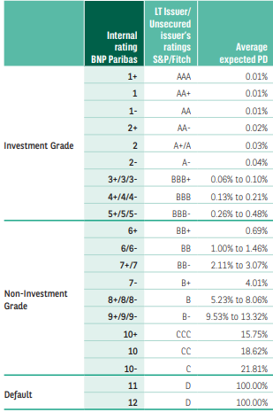

**Rating System**

Each counterparty is rated internally by the Group using uniform principles, regardless of the approach used to calculate regulatory capital requirements.

The Bank has a comprehensive internal rating system compliant with regulatory requirements regarding capital adequacy. A periodic assessment and control process has been deployed within the Bank to ensure that the system is appropriate and correctly implemented.

The Group has developed an indicative equivalence between the Bank’s internal ratings and the long-term issuer ratings assigned by the major rating agencies.

**Credit risk as of 31 Dec 2022:**

The RWA relating to credit risk as at 31 December 2022 and comparative information for 31 December 2021 are reflected below:

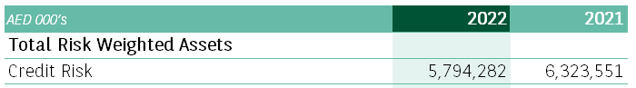

**Counterparty credit risk**

Counterparty credit risk is the translation of the credit risk embedded in financial transactions, investments and/ or settlement transactions between counterparties. Those transactions include bilateral contracts such as over-the-counter (OTC) derivative contracts as well as contracts settled through clearing houses. The amount of this risk may vary over time in line with changing market parameters which then impacts the replacement value of the relevant transactions.

Counterparty risk lies in the event that a counterparty defaults on its obligations to pay the Bank the full present value of the flows relating to a transaction or a portfolio for which the Bank is a net receiver. Counterparty credit risk is also linked to the replacement cost of a derivative or portfolio in the event of counterparty default. Hence, it can be seen as a market risk in case of default or a contingent risk

**Credit Valuation Adjustment:**

The valuation of financial OTC trades carried out by BNP Paribas as part of its activities (mainly Global Markets) includes Credit Valuation Adjustments (CVA). CVA is an adjustment of the trading portfolio valuation to take into account each counterparty’s credit risk. It is the fair value on any expected loss arising from counterparty exposure based on the potential positive value of the contract, the counterparty default probability and the estimated recovery rate in case of default. The majority of counterparty credit risk exposures on derivatives are related to the interest rate, credit and foreign exchange activities, all underlying assets, and all business lines combined.

**Measurement:**

At BNP Paribas UAE, counterparty credit risk is calculated in line with Central bank of UAE regulations. Simple Alternative approach is used for measurement of CVA capital which is set at equivalent level to CCR.



# **MARKET RISK**

Market risk is the risk of incurring a loss of value due to adverse trends in market prices or parameters, whether directly observable or not.

Observable market parameters include, but are not limited to exchange rates, prices of securities, prices of derivatives, and other parameters that can be directly inferred from them, such as interest rates, credit spreads, volatilities and implied correlations or other similar parameters.

Non-observable factors are those based on working assumptions such as parameters contained in models or based on statistical or economic analyses, non-ascertainable in the market

**Market Risk management**

At BNP Paribas UAE branches the relevant market risk is due to foreign exchange movement.

Foreign exchange risks related to banking activities and are managed by the cross-functional ALM Treasury Department. At Group level, the ALM Treasury Department is directly overseen by the Group Senior Executive Advisor. BNP Paribas SA’s ALM Treasury Department exercises functional authority over the ALM Treasury teams of each entity including BNP Paribas UAE branches.

**Market risk as at 31 Dec 2022**

Risk weighted assets for market risk at 31 December 2022 and comparative information for 31 December 2021 are reflected below are reflected below:

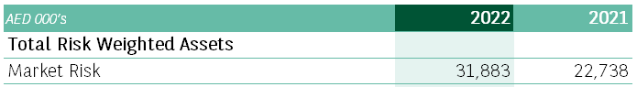

# **OPERATIONAL RISK**

Operational risk is the risk of incurring a loss due to inadequate or failed internal processes, or due to external events, whether deliberate, accidental or natural occurrences. Management of operational risk is based on an analysis of the “cause – event – effect” chain.

Internal processes giving rise to operational risk may involve employees and/or IT systems. External events include, but are not limited to floods, fi re, earthquakes and terrorist attacks. Credit or market events such as default or fluctuations in value do not fall within the scope of operational risk.

Operational risk encompasses fraud, human resources risks, legal risks, non-compliance risks, tax risks, information system risks, conduct risks (risks related to the provision of inappropriate financial services), risk related to failures in operating processes, including loan procedures or model risks, as well as any potential financial implications resulting from the management of reputation risks.

**Operational Risk management**

The general internal control system at BNP Paribas underpins management of operational, compliance and reputation risks as part of its dual-level system to ensure periodic and permanent control.

The operational risk management and control system for the Group as a whole is structured around a two-level system with the following participants:

* First level of defence: operational staff, notably the Heads of operational entities, business lines and functions, who are on the frontline of risk management and implementation of systems to manage these risks;
* Second line of defence: the functions exercising second level control that are responsible for the organisation and proper functioning of the risk management system and its compliance with laws and regulations for their area of expertise as defined in their Responsibility Charter. These teams are, in particular, responsible for:

- coordinating, throughout the areas within their remit, the definition and implementation of the permanent control and operational risk identification and management system, its standards and methodologies, reporting and related tools,

- acting as a second pair of eyes, independently of the Heads of operational entities, to scrutinise operational risk factors and the functioning of the operational risk and permanent control system, and issuing warnings, where appropriate

**Operational Risk as at 31 Dec 2022**

Risk weighted assets for operational risk at 31 December 2022 and comparative information for 31 December 2021 are reflected below are reflected below:

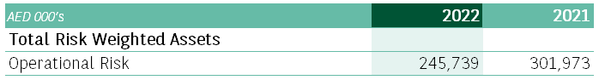

# **LIQUIDITY RISK**

Liquidity risk is the risk that the bank will not be able to honor its commitments or unwind or settle a position due to the market environment or idiosyncratic factors within a given timeframe and at a reasonable cost.

Liquidity risk reflects the risk of not being able to fulfil current or future foreseen or unforeseen cash or collateral requirements, across all time horizons, from the short to the long term.

This risk may stem from the reduction in funding sources, draw down of funding commitments, a reduction in the liquidity of certain assets, or an increase in cash or collateral margin calls. It may be related to the bank itself (reputation risk) or to external factors (risks in some markets).

**Liquidity Risk management**

The Branch’s liquidity risk is managed under a global liquidity policy approved by the BNP Paribas Group’s ALM Committee. This policy is based on management principles designed to apply both in normal conditions and in a liquidity crisis. The liquidity position is assessed on the basis of internal indicators and regulatory ratios

**Liquidity Risk as at 31 Dec 2022:**

***Eligible Liquid Assets Ratio (ELAR)***

ELAR is calculated in accordance with Circular No 33/2015 issued by the Central bank Of UAE.

ELAR as at 31 December 2022 and comparative information for 31 December 2021 are reflected below:

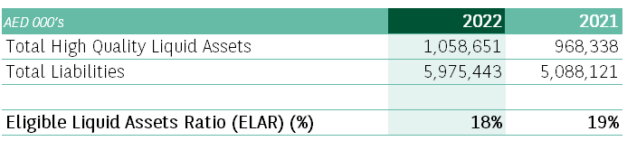

***Advances to Stables Resource Ratio***

Advances to Stable Resources Ratio is calculated in accordance with Circular No 394 issued by the Central bank of UAE and should not exceed 100%.

Advances to Stable Resources Ratio as at 31 December 2022 and comparative information for 31 December 2021 are reflected below:

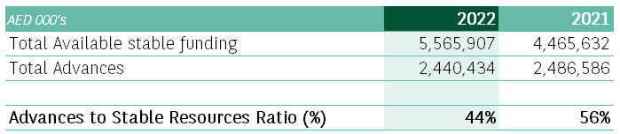

# **LEVERAGE RATIO**

The leverage ratio’s main objective is to serve as a complementary measure to the risk-based capital requirements (back-stop principle). It is calculated as the ratio between Tier 1 capital and an exposure measure calculated using on- and off-balance sheet commitments valued using a prudential approach.

Leverage Ratio as at 31 December 2022 and comparative information for 31 December 2021 are reflected below:



# **REMUNERATION**

BNP Paribas UAE Branch follows the BNP Paribas Group compensation guidelines and compensation policy.

*The BNP Paribas Group Compensation document can be found under:* [*https://invest.bnpparibas.com/en/compensation-regulated-employees*](https://invest.bnpparibas.com/en/compensation-regulated-employees)

The BNP Paribas Group compensation principles and compensation policy are designed and proposed by Group Human Resources in cooperation with the relevant business lines. They are presented for validation to the Group Compliance, Risk and Finance Committee (CRIF), chaired by the General Management, and then presented to the Compensation Committee before approval by the Board of Directors. Since 2014, the General Shareholders Meeting is annually consulted on some subjects.

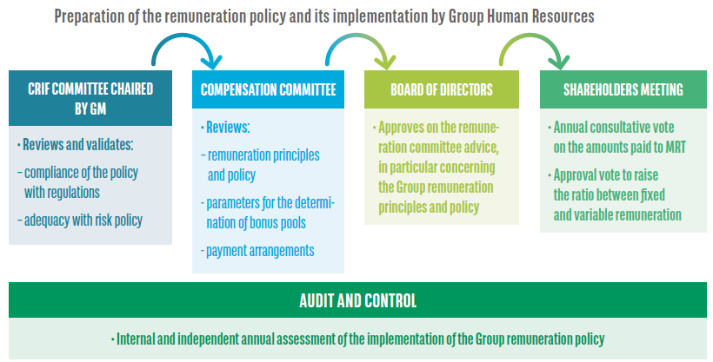

Compensation for Branch employees whose professional activities have a significant impact on the Branch’s risk profile:

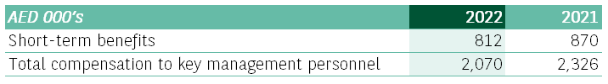

# **APPENDIX**

